HOW TO RECORD MOVES?

Abbreviation of pieces:

King = K
Queen = Q
Rook = R
Bishop = B
Knight = N

With pawn, we need only to write the name of square it moves to.
Example:
Kg2, Hf6, Rd6, Bg8, Nd2…
If there are 2 pieces which can move to the same square, we need to add the original file or rank of the moving piece.
Example:

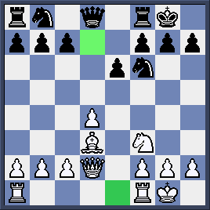
White two Rooks can move to e1 (a highlighted square) we then write Rae1 or Rfe1.
Similarily, Black two Knights can move to d7 (a highlighted square). We have two ways to record Nbd7 or Nfd7 (1st way); N8d7 or N6d7 (2nd way).

Other symbols :

Kingside Castling: 0-0
Queenside Castling: 0-0-0
Capture: x
Check: +
Double check: + +
Checkmate : #

Example:
Bxd6 + (Bishop captures at d6 with check)
Nf7 # (Knight moves to f7 with checkmate )
Rc7 + + (Rook moves to c7 with double check)

How to record pawn moves?
As said above, we just need to write the square it moves to.
Example: c5 (Pawn moves to c5)
If pawn captures, we add its original file.
Example: d x c3 (Pawn from d- file captures at c3)
Pawn promotion
Example: e8/Q + (Pawn moves to e8 promoting to Queen with check)
g x f8/ N # (pawn from g- file captures at f8 promoting to Knight with checkmate)

How to record a position?
We record the position by the following rules: from the high value piece to the pawn and from the Queenside to Kingside. For example, we can record the following game as:

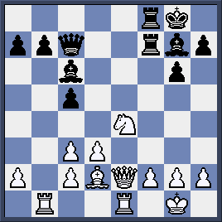
White: Kg1, Qe2, Rb1, Re1, Bd2, Ne4, a2, c2, c3, d3, f2, g2, h2
Black: Kg8, Qc7, Rf8, Rf7, Bc6, Bg7, a7, b7, c5, g6, h7

How to evaluate the move and position?

! Good move
! ! Excellent move
? Mistake
?? Blunder
!? Interesting move
?! Dubious move
+= White has a slight advantage unclear position

=+ Black has a slight advantage
+/- White has a clear advantage
-/+ Black has a clear advantage
+ - White has a winning advantage
- + Black has a winning advantage
= Equal postion

- Quizzes:
- Replay the following game:
Kasparov - Fridrich (Simultaneous play in Czech Republic)
- e4 e5 2. Nf3 d6 3. d4 Bg4 4. dxe5 Bx f3 5. Qxf3 dxe5 6. Bc4 Qf6 7. Qb3 b6 8. Nc3 Bc5 9. 0-0 c6 10. Be3 Nd7 11. Rad1 Rd8 12. Bxc5 bxc5 13. Qb7 Ne7 14. Rd3 Nc8 15. Rxd7 Rxd7 16. Qxc8+ Rd8 17. Qf5 Qxf5 18. exf5 0-0 19. b3 Rd2 20. Bd3 a5 21. Ne4 a4 22. Nxd2 axb3 23. cxb3 Rd8 24. Bc2 Rxd2 25. Rd1 Rxd1 26. Bxd1 1-0
- Record the following position:

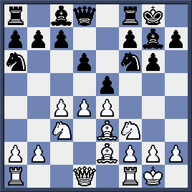
White
Black ………………………………………………………………………….

